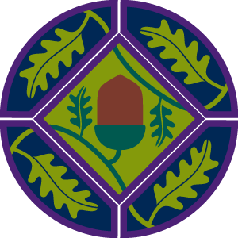
Scouts Scotland’s Young Leaders’ Scheme
The Young Leaders' Scheme is just one of the exciting programme elements of being an Explorer Scout. All leaders in the Beaver Scout, Cub Scout and Scout Section who are between the ages of 14 and 18 are considered to be Young Leaders. They are Explorer Scouts who choose to devote a large proportion of their time in Scouting to service in another section. The Young Leaders' Scheme helps Explorer Scouts to develop and grow as individuals. They benefit from personal impacts such as greater employability and self-confidence. It allows them to make a valuable contribution to their community and give service to others. The scheme also helps them fulfil the service elements of other awards such as Chief Scout’s Award and The Duke of Edinburgh’s Award.
Young Leaders from all over Scotland are supported to attend training events with other Young Leaders and to complete missions, which let them put what they have learned into practice. These training events take young people out of their comfort zones, often in unfamiliar settings, to learn how to be compassionate and responsible leaders.
In this case study, we caught up with three Young Leaders; Zoe, Timmy and Richard who were attending a training event at Scout Adventures Lochgoilhead where they reflected on their experiences as Young Leaders, the skills and confidence they have gained as a result of their increased responsibility and their hopes for the training event.
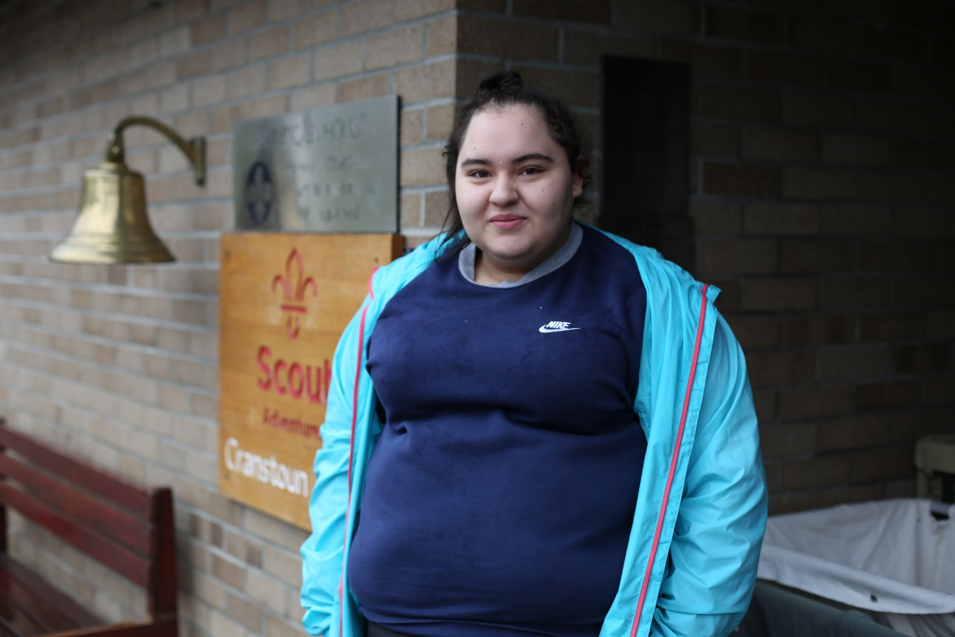
Scouts’ Young Leaders develop confidence and other transferable skills. These include understanding different leadership styles, how to communicate effectively and consider accessibility when planning activities, so that young people with different abilities, needs and interests can take part. They gain experience of planning and delivery, to embed this learning in practice.
Zoe: “Being a Young Leader has helped me because I want to be a child carer when I’m older, I’ve gained experience, and this gets me out a lot more. It’s helped me get to know people and speak to them and build my confidence.”
Timmy: “It definitely helps with team-working skills, and working with people you’ve never met or don’t really know well, it definitely has helped me with that so far. So I’d imagine that doing this weekend, especially cause I’ll have to work with others, will help me even more.”
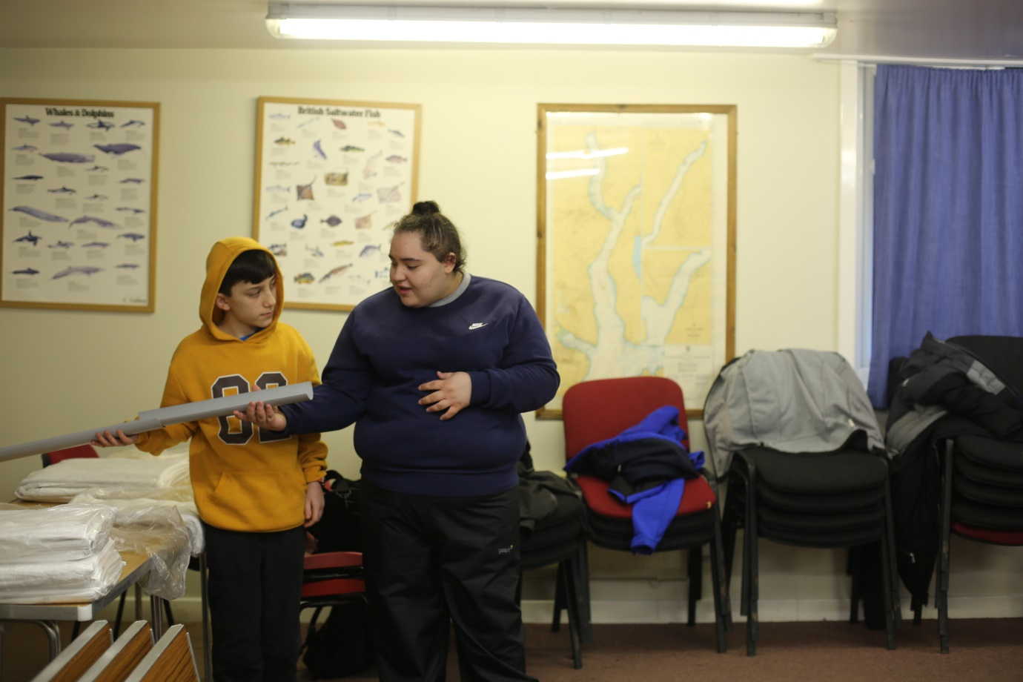
Weekends away and residential programmes offer young people the space and time to develop and learn new things.
Zoe: “We’re learning activities that we can take back to the younger Scouts. We’re going to go hill climbing and then we’re doing high ropes. I’m not really keen on heights but it’ll help me get over the fear.”
Timmy: “I want to learn new tips on how to handle the young children in groups and how to deal with certain issues that may arise, and making sure Scouts are inclusive for everyone. It’s a worthwhile experience, it’s great fun, you can’t really do Young Leader-ing if you don’t know what you’re doing.”
Richard: “It used to be that I wouldn’t really like going in front of people, but I’ve grown more confident as a person. I won’t be nervous but then like five minutes before I’ll get a rush, and then when I’m doing it, it all calms down, and I’m just completely fine. I always try and keep that – if it’s something I don’t like, I just think it’ll be alright, and it normally is.”
At this training event, the Young Leaders including Zoe, Timmy and Richard worked together on sessions including taking the lead, understanding behaviour, learning through games, making Scouting accessible, programme planning, communication and first aid. These sessions were delivered in a mix of indoor and outdoor environments typical of a Scouting programme.
They received a certificate of participation and an action plan for how to put all that they have learned into practice when they returned to their respective Beaver Scout, Cub Scout and Scout sections. The action plan is delivered through a series of missions, which when completed, the Young Leaders will receive the Young Leader’s Award.

