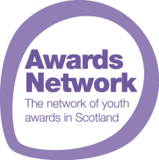
Make your voice heard and become part of the
Awards Network’s Youth Forum
We want to hear your opinions on recognition of wider learning and achievements. What is your youth award story and how has that journey impacted your life? Should youth awards be as valued as formal qualifications? What do think the Awards Network’s priorities should be?
Join the Awards Network’s Youth Forum and tell your stories. We are looking for young people aged 16-24 who want to share their ideas and experiences to help us improve our impact. The Youth Forum will meet at the end of November for the first time so get in touch with us before 31 October.
As a member of the Youth Forum, you will have a chance to gain experience of volunteering on a national committee. There will be lots of interesting and exclusive events you will be able to attend as a Youth Forum ambassador.
Application Form: your details
Name: | Age:
Contact details: | Details of any dietary or access requirements:
Have you completed an award or are you in the process of completing one? If so which one?
Please tell us why you would like to be part of the Awards Network’s Youth Forum:
What skills or experience are you hoping to gain?
What would be your preferred first 2019 meeting date? Please tick. | 23 November O 30 November O
Do you consent to your photo being taken or being filmed for the purposes of the Awards Network’s Youth Forum and the Awards Network promotion which may also be shared via the Awards Network social media channels? | YES O NO O

Please send the completed form to Awards Network c/o Youth Scotland, Balfour House, 19 Bonnington Grove, Edinburgh, EH6 4BL or email it to contact@awardsnetwork.org before 31 October 2019 deadline.

